PROJECT REPORT TEMPLATE
1. INTRODUCTION:
1.a.Overview:
The virtual background feature allows you to display an image or video as your background during a zoom meeting,which can provide you with more privacy or a consistent and professional look for a presentation .Depending on the device you can use the virtual background feature with or without the use of green screen behind you ,with the system requirements being higher for virtual background without a green screen.
1.b.Purpose:
Employers can also make use of the virtual background feature .They can easily add a professional touch to their online meetings by requesting all their employees to use the same brand images as their virtual background.
2. PROBLEM DEFINTION AND DESIGN THINKING:
2.a. EMPATHY MAP:
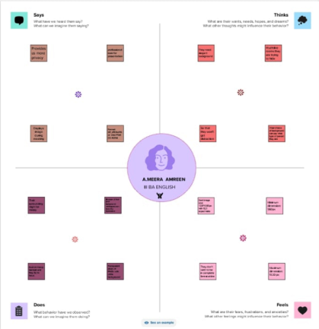
2.b. BRAINSTROMING:
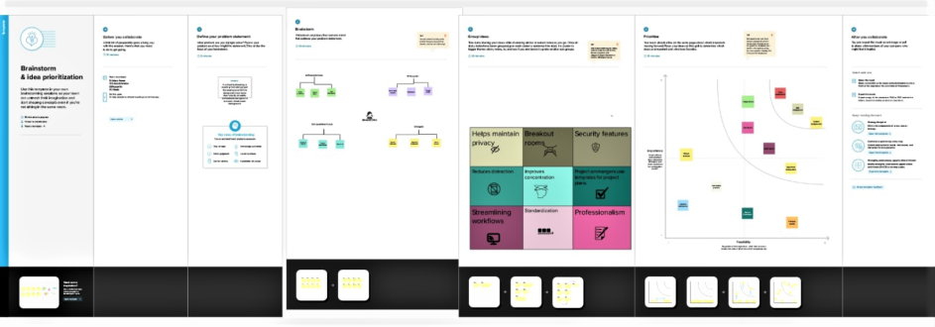

3.RESULT:
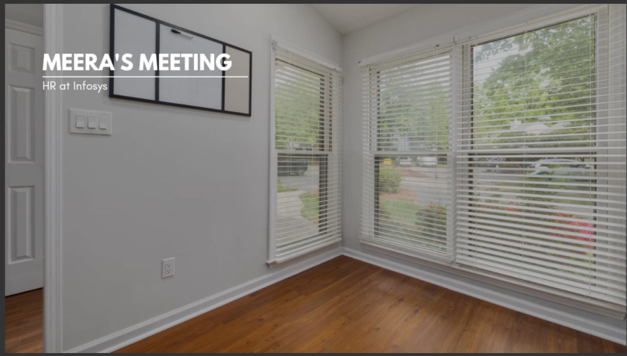
4.ADVANTAGES:
- They can easily add a professional touch to their online meetings
- They not only maintains uniformity but also helps employees to stay focused during conversations
DISADVANTAGES:
- The background chosen most often doesn’t match the purpose or tone of the
Meeting
- Eg: A tropical island paradise might be great for happy hour but not so much for work
5.APPLICATIONS:
- Cyberlink PerfectCam,Snap camera,NVIDIA broadcast ,XSplit VCam
ChromaCam.
6.COCLUSION:
I have learnt to design a virtual zoom background with the help of Canva .It is very helpful for online meeting works and jobs in this technological world.

